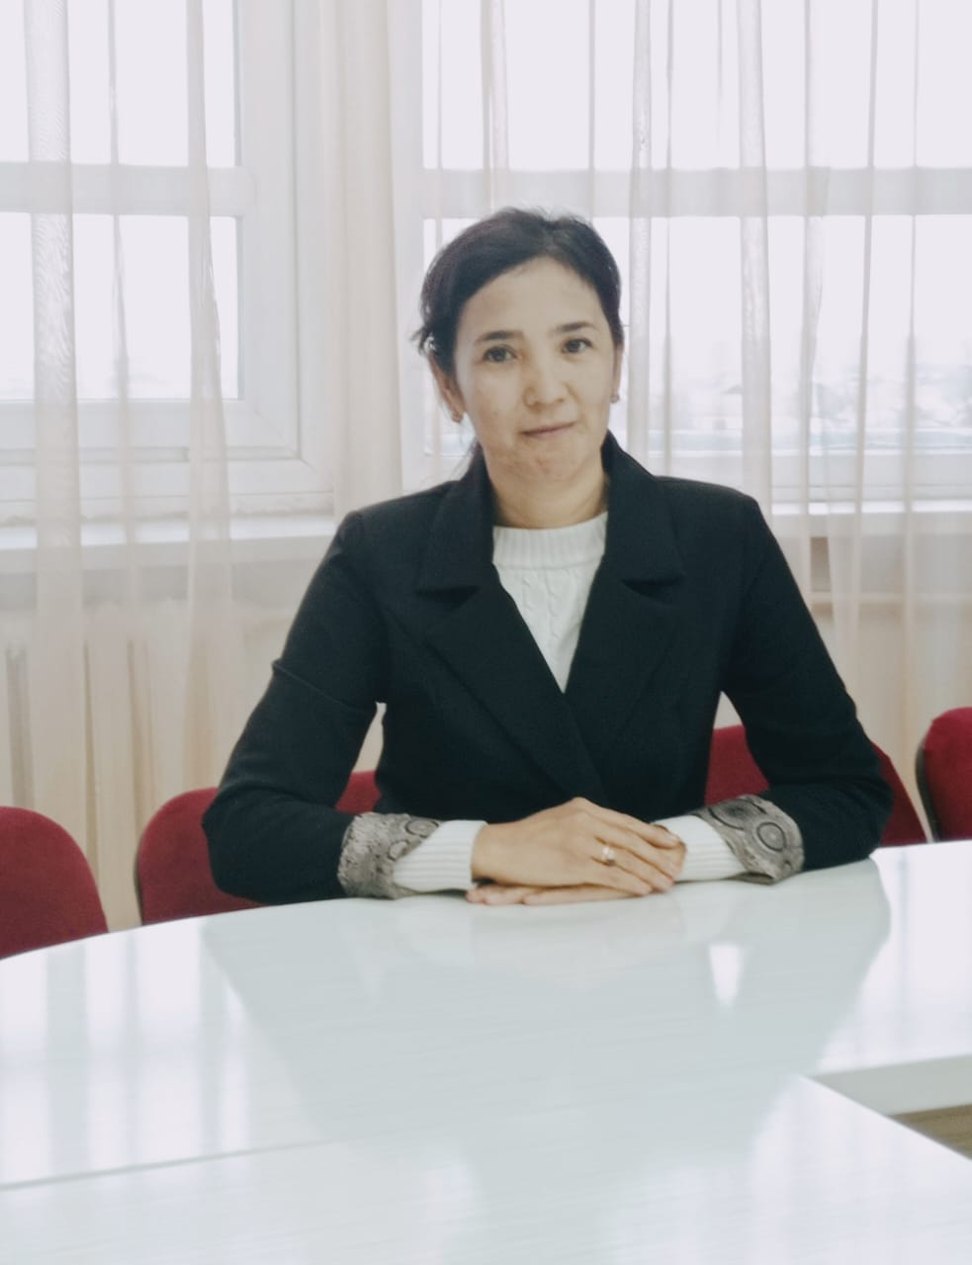

**КАЛДЫБАЕВА Айнур Отарбаевна,**

**С.Нұрмағамбетов атындағы №72 жалпы орта білім беретін мектебінің ағылшын тілі пәні мұғалімі.**

**Шымкент қаласы**

**THE SOLAR SYSTEM**

|  |  |
| --- | --- |
| **Learning objectives(s) that this lesson is contributing to:** | 10.1.5 Use feedback to set personal learning objectives;  10.3.7 Use appropriate subject-specific vocabulary and syntax to talk about a range of general and curricular topics. |
| **Lesson objective** | Demonstrate feedback to set personal learning objective;  Demand vocabulary and syntax to talk about a range of general and curricular topics. |

**Plan:**

|  |  |  |  |  |
| --- | --- | --- | --- | --- |
| **Part of the lesson/Time** | **Teacher’s activity** | **Student’s activity** | **Assessment** | **Resources** |
| **Beginning of the lesson**  **Pre-learning**  **«Brainstorming» method**  **10 min.** | **Greeting**  **-**Good morning, students!  -What is it doing?  -What is it day?  Let’s revise the previous lesson materials with the space exploration.  Before yesterday we talked about space exploration. **Questions:**  1.What are the negative and positive aspects of space exploration?  2 How do you think do we need to explore outer space?  3 Is it right to found the money for this?  Before starting our lesson, I would like to show you one video, according to the video you have to guess the theme of our open lesson.  -Yes, you are right. Brilliant !The Solar System.  Looking at the whiteboard , they should copy out the new words concerning the theme.  **Aim:** to consolidate new vocabulary:  Asteroid-астероид Astronomy-астроном Blast-жарылыс  Colony-колония  Comit-комета Constellation-шоқ жұлдыз  Eclipse-тұтылу Explore-зерттеу  Gas giant-газовый гигант  Gravity-ауырлық күші Land-жерге қону  Milky Way-құс жолы Satellite-спутник | Students great teacher and answer to the questions  S.s gives their possible answers  Students watch the video by themselves and guess the theme.  Learners said own opinion.  Students acquainted with new vocabulary | Differentiation: “Conclusion methods” –3 points  Ss answer for the questions.  Ss evaluate each other and encourage classmate with phrases like:  Well done!  Encourage Ss who answer the questions  Oral feedback  -Excellent  -Good job  **Assesstment**  **technique:**  Oral feedback  -Great  -Good job! | Whiteboard  Students Book  Whiteboard  Whiteboard  hhtps:\\youtube.com\shorts\Izsf1-vMUdy?si6scrR59Zm2ZOJ-Se  Whiteboard |
| **Middle of the lesson**  **Presentation part**  **10min.** | **Task 1.Listening quiz.** Answers 1.Thesun, 2.Mercury. 3.Saturn.4.ice,dust and gas,5.Europa,6.New Horizons.  **Task 2 .Mark the statements with T(True) or F (False).** 1. Mercury is the smallest planet in the Solar System? 2. Earth of the third planet in the Solar System? 3.The asteroid is made of water and ice that moves around the Sun? 4. Venus faces the Sun and has a very high temperature of 430 Oc. 5.The Earth has surrounded by a layer of gases known as the atmosphere. 6.Jupiter is 58 million km from the Sun. 7. There are nine planets in the Solar System? 8. A star is an object in space that gives out light and heat. | Students attentively watch it, then answer the teacher’s questions.  Students read and mark the true\false.  S.s answers the questions | **Descriptor:**  - **Give right answer**  **- Listen and check**  - Find the true or false  - Answer for questions  Students give answer  1.true 7.false  2.true 8.true  3.false  4.false  5.true  6.false  Oral feedback  -Good  -Excellent |  |
| **5 min.** | **Task 3**.Complete the fact file with the following words\phrases | Answers\key  1.asteroid 2.solar 3.gas giants 4.rings 5.spacecraft | Descriptor:  Read sentences  Match them  Translate them  Check Ss’answers |  |
| **Conclusion**  **7 min.** | Home task is to learn new words. Ex 1. P 81 |  | Oral feedback  -Excellent  -Good job  -Brilliant | Paper  St.book |
| **End of the lesson.** | Feedback  Thank you very much. I think you understand todays grammar theme.  You have worked very well today.  Bye-bye!  Home task: to be ready for speaking task and prepare of different types of Intelligences theory | Ss use their stickers to show their knowledge according to the lesson  1- I understood  2-I have some questions  3-I need a help. | Students  -choose one of the variant |  |